COURSE CODE: ECA1503
COURSE NAME: TRANSMISSION LINES AND WAVE GUIDES
NAME: G. Bhanu Siva Mani Ram
Reg.No:192412471
2 | Design a rectangular waveguide operating in the X-band using CST. Simulate the TE(_{10}) mode and evaluate the cutoff frequency.

AIM
To design and simulate a WR-90 rectangular waveguide operating in the TE₁₀ mode using CST Studio Suite and determine its cutoff frequency and S-parameter performance.

2. PROCEDURE
- Open CST Studio Suite and create a new microwave project.
- Select Time Domain Solver and set the frequency range to 6–12 GHz.

- Create a rectangular waveguide with:
  - Width $a=22.86$mm
  - Height $b=10.16$mm
  - Length = 100 mm

- Assign copper as the conducting material.
- Add Waveguide Port 1 at the input and Port 2 at the output.
- Select the TE₁₀ mode for excitation.
- Set suitable open/metal boundary conditions and generate the mesh.
- Run the CST simulation.
- Observe the electric-field distribution and S11/S21 parameters.

OUTPUT:
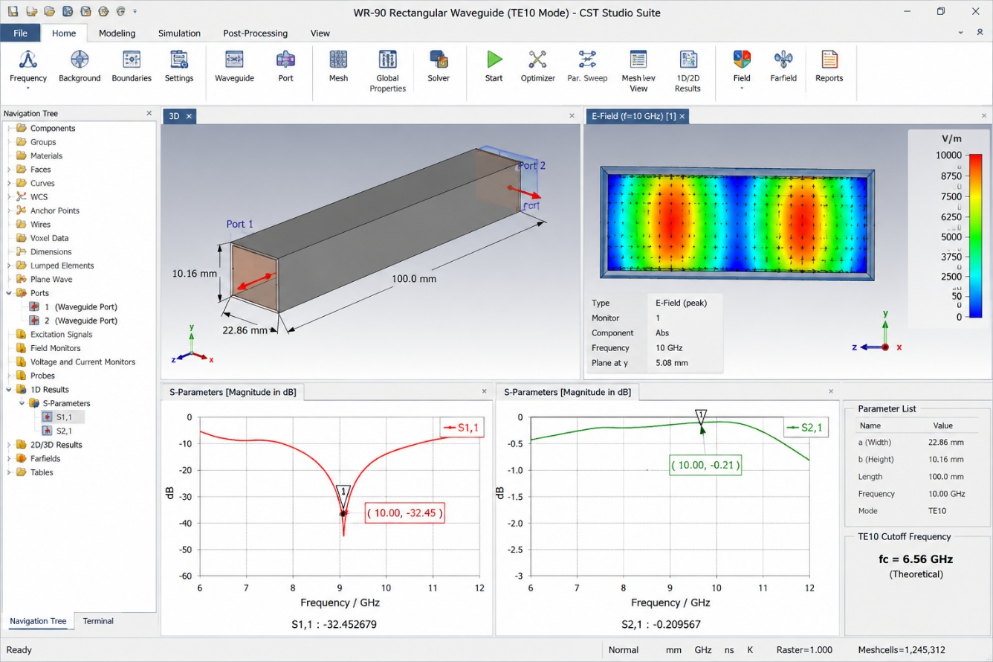

3. RESULT
The theoretical cutoff frequency for the dominant TE₁₀ mode is:
$$f_{c}=\frac{c}{2a} \\ f_{c}=\frac{3×{10}^{8}}{2\left(22.86×{10}^{-3}\right)} \\ \boxed{f_{c}=6.56\text{ GHz}}$$
The simulation confirms TE₁₀ mode propagation above 6.56 GHz. The electric-field distribution shows the expected TE₁₀ field pattern, while the S-parameter plots can be used to evaluate reflection and transmission.

